

FACULTY OF COMPUTER SCIENCE AND

INFORMATION TECHNOLOGY

UNIVERSITI MALAYA

WIA3002 ACADEMIC PROJECT 1 REPORT

EVIDENCE-GROUNDED CLINICAL DECISION SUPPORT FOR WOUND DRESSING RECOMMENDATION: A RETRIEVAL-AUGMENTED GENERATION FRAMEWORK BASED ON THE T.I.M.E. ASSESSMENT FRAMEWORK

Prepared By:
TEE QI JING (23004894)

Supervised By:
DR. SAW SHIER NEE

EVIDENCE-GROUNDED CLINICAL DECISION SUPPORT FOR WOUND DRESSING RECOMMENDATION: A RETRIEVAL-AUGMENTED GENERATION FRAMEWORK BASED ON THE T.I.M.E. ASSESSMENT FRAMEWORK

TEE QI JING

FACULTY OF COMPUTER SCIENCE AND

INFORMATION TECHNOLOGY

UNIVERSITI MALAYA

KUALA LUMPUR

2026

EVIDENCE-GROUNDED CLINICAL DECISION SUPPORT FOR WOUND DRESSING RECOMMENDATION: A RETRIEVAL-AUGMENTED GENERATION FRAMEWORK BASED ON THE T.I.M.E. ASSESSMENT FRAMEWORK

TEE QI JING

REPORT SUBMITTED IN FULFILMENT OF THE
REQUIREMENTS FOR THE DEGREE OF COMPUTER
SCIENCE (ARTIFICIAL INTELLIGENCE)

FACULTY OF COMPUTER SCIENCE AND
INFORMATION TECHNOLOGY
UNIVERSITI MALAYA
KUALA LUMPUR

2026
UNIVERSITY OF MALAYA
ORIGINAL LITERARY WORK DECLARATION

Name of Candidate: TEE QI JING (I.C/Passport No: 041227-04-0359)

Matric No: 23004894

Name of Degree: Bachelor of Computer Science (Artificial Intelligence)

Title of Project Paper/Research Report/Dissertation/Thesis (“this Work”): Evidence-Grounded Clinical Decision Support For Wound Dressing Recommendation: A Retrieval-Augmented Generation Framework Based On The T.I.M.E. Assessment Framework

Field of Study:
I do solemnly and sincerely declare that:
- I am the sole author/writer of this Work;
- This Work is original;
- Any use of any work in which copyright exists was done by way of fair dealing and for permitted purposes and any excerpt or extract from, or reference to or reproduction of any copyright work has been disclosed expressly and sufficiently and the title of the Work and its authorship have been acknowledged in this Work;
- I do not have any actual knowledge nor do I ought reasonably to know that the making of this work constitutes an infringement of any copyright work;
- I hereby assign all and every rights in the copyright to this Work to the University of Malaya (“UM”), who henceforth shall be owner of the copyright in this Work and that any reproduction or use in any form or by any means whatsoever is prohibited without the written consent of UM having been first had and obtained;
- I am fully aware that if in the course of making this Work I have infringed any copyright whether intentionally or otherwise, I may be subject to legal action or any other action as may be determined by UM.

Candidate’s Signature Date:

Subscribed and solemnly declared before,

Witness’s Signature Date:

Name:
Designation:

Acknowledgement
I would like to express my sincere thanks to everyone who supported and contributed to the completion of this project. First and foremost, a special thanks goes to my supervisor, Dr. Saw Shier Nee, for her on-going guidance and support throughout the project development. Her advice and insights were exceptional and greatly helped shape the outcome of the project.

I am also very grateful to and would like to thank Dr. Nurul Japar and Prof. Dr. Chan Chee Seng, the panel members, for giving me valuable feedback on my project. Their perspectives and suggestions during the monitoring and viva suggestions truly helped push this project to a higher standard.

Additionally, I want to thank the faculty and staff for providing a supportive environment and the resources during the project development. I would like to thank my clinical stakeholder, Ms. Saw Shier Khee, general surgeon at Sultan Ismail Hospital Johor Bahru, for her valuable commitment to the project through frequent discussions and meetings. Besides, I am deeply grateful to my project partner and seniors, Wing Teng, Micole and Boon Ping for the collaboration and dedication, leading to a meaningful integration of the project.

Finally, a heartfelt thank you goes to my family and friends for their encouragement and motivation. This journey would have been much harder without their support.

Abstract
This project proposes the use of an evidence-based Retrieval-Augmented Generation (VerdaSenseRAG) model to provide recommendations of wound dressings based on both structured clinical inputs (standardized by T.I.M.E. framework – Tissue, Infection, Moisture, Edge) and on the free-text clinical notes provided by patients. Importantly, this RAG aims to be part of an end-to-end mobile health pipeline which is accompanied by other upstream companion Computer Vision models to extract visual features and provide accurate, grounded inputs. A systematic ablation study will take place to evaluate the clinical validity, safety and completeness of recommendations generated by the VerdaSenseRAG to a wound care standard via automated evaluation metrics and human-in-the-loop clinician reviews. Lastly, the VerdaSenseRAG module will be integrated in a smartphone-based wound management app to evaluate its practicality for deployment and its responsiveness in acceptable latency. The aim of this framework is to ease the self-care process of wound, especially for mobility-limited patients, while ensure it is secure, highly reliable. and able to minimize the LLM factual inaccuracies of generated recommendations.

Keywords: LLMs, RAG, clinicians, dressing recommendations, wound care, T.I.M.E framework

Table of Contents

Acknowledgement 5
Abstract 6
Table of Contents 7
List of Tables 9
List of Figures 10
1.0 Introduction to Project 11
1.1 Overview 11
1.2 Problem Statement 12
1.2.1 Ideal Clinical Scenario 12
1.2.2 Existing Limitations and Research Gaps 12
1.2.3 Proposed Solution: VerdaSenseRAG 13
1.3. Project Objectives 14
1.4. Project Research Questions 14
1.5 Project Scope 15
1.6 Project Timeline 17
2.0 Literature Review 18
2.1 Wound Management and Assessment: The T.I.M.E. Framework 18
2.2 Wound Care AI: Computer Vision, Classification, and Assessment Automation 19
2.3 LLMs, Retrieval-Augmented Generation, Hallucination, and Clinical Grounding 20
2.4 Retrieval-Augmented Generation in Clinical Medicine: Foundational Work and Convergent Evidence 21
2.5 Mobile Deployment of Medical RAG and Clinical Applications 22
2.6 Research Gap and Justification 23
3.0 Methodology 24
3.1 System Overview 24
3.2 System Inputs and Outputs 24
3.2.1 Upstream Companion Models and System Inputs 24
3.2.2 System Outputs 26
3.3 Knowledge Base Ingestion Pipeline 27
3.3.1 Data Source Selection and Clinical Guideline Collection 27
3.3.2 Document Preprocessing and Manual Curation Strategy 28
3.3.3 Metadata Schema and AI-Assisted Summarization 29
3.3.4 Embedding Model and Vector Store 29
3.4 Retrieval Pipeline 30
3.4.1 T.I.M.E. Input Normalization 30
3.4.2 Rule-Based Clinical Pre-Classifier 30
3.4.3 Multi-Axis Query Construction 30
3.4.4 Hybrid Retrieval with Reciprocal Rank Fusion 31
3.5 Generation Pipeline 33
3.6 Evaluation Framework and Proposed Ablation Study 34
3.6.1 Testset Construction 34
3.6.2 Automated RAGAS Evaluation Framework 35
3.6.3 Rule-Based Safety Checker 37
3.6.4 Human Clinical Expert Evaluation 37
3.6.5 Proposed Ablation Study Design 37
4.0 System Analysis and Design 40
4.1 Architecture Pipelines 40
4.1.1 Knowledge Base Ingestion Pipeline 40
4.1.2 Retrieval and Generation Pipeline 41
4.1.3 Evaluation Pipeline 42
4.2 Requirements Analysis 43
4.2.1 Functional Requirements 43
4.2.2 Non-functional Requirements 43
5.0 Technical Implementation 44
6.0 Conclusion 45
7.0 References 46
Appendix 51

List of Tables
Table 1: FYP1 Project Schedule 18
Table 2: System Output Fields 27
Table 3: Clinical Guideline Collection 29
Table 4: Test Set Construction 35
Table 5: Retrieval Ablation Metric Suites 37
Table 6: Generation Ablation Metric Suites 37
Table 7: Proposed Retrieval Ablation Experiments 39
Table 8: Proposed Generation Ablation Experiments 40
Table 9: Functional Requirements 44
Table 10: Non-functional Requirements 44
Table 11: Technical Implementations 45

List of Figures
Figure 1: VerdaSense RAG Ingestion Pipeline 41
Figure 2: VerdaSense RAG Retrieval & Generation Pipelines 42
Figure 3: VerdaSense RAG Evaluation Pipeline 43
Figure 4: Logbook of meetings with supervisors 52
Figure 5: Collaboration Letter 53
Figure 6: Meetings with supervisor 53
Figure 7: Meetings with collaborator 54

Introduction to Project

1.1 Overview
Wound management is a significant and growing clinical challenge especially in elderly patients with chronic conditions like vascular diseases and diabetes. Globally, chronic wounds affect an estimated 6.5 million individuals in the United States alone, costing more than USD 25 billion in annual treatment costs (Sen et al., 2009). For those who are living in rural and mobility-limited patients, as they are constantly facing difficulties in routine face-to-face (f2f) clinical follow-ups, and this is where the telemedicine shows a valuable alternative for improving access and convenience for wound assessment along with self-caring (Rabbani et al., 2025). Recent progress of Artificial Intelligence (AI) in the wound care domain shows the ability of computer vision systems in various clinical tasks, including wound segmentation, tissue semantic classification, and infection detection. However, most of the current CV-based solutions reach only the stage of wound assessment, and lack to the further work on the actionable recommendations for wound dressing. At the same time, baseline Large Language Models (LLMs) are prone to hallucination in generating clinically plausible, but unsupported recommendations that might lead to clinical risks. The proposed project is VerdaSense RAG, which is a downstream recommendation system of an end-to-end mobile health pipeline. The system receives T.I.M.E. outputs from companion computer vision models along with patient-provided clinical notes to retrieve clinically relevant evidence from curated knowledge base and generates structured recommendations on appropriate wound dressings.

1.2 Problem Statement

1.2.1 Ideal Clinical Scenario
Imagine a 62-year-old patient with Type 2 diabetes who is living in a rural area and is dealing with a diabetic foot ulcer (DFU) that is not healing within 6 weeks. Due to mobility issues, the patient is facing difficulties in scheduling regular follow-ups to the hospital or a specialist wound clinic. In an ideal clinical scenario, the patient could simply take a picture of the foot ulcer using a smartphone and submit the wound image through a clinical AI-based wound assessment application. They could then receive a clear and comprehensive self-care plan including T.I.M.E. wound assessment, evidence-based dressing recommendations with step-by-step instructions for self-care of the wound at home. Besides, for clinically severe or infected wounds, the patient would be warned to be urgently escalated to the hospital or specialist wound care clinic for emergency treatment. For nurses and general practitioners (GP), they could also review the photo of patients’ wound images alongside the app’s recommended treatment and verify the clinical reliability and accuracy from the cited clinical guideline sources. This automated process of wound assessment with dressing recommendations provides a clinically safe, time-saving solution that bridges the gap of mobility issues faced by patients and encourages patients to actively participate in their wound healing journey.

1.2.2 Existing Limitations and Research Gaps
While the ideal scenario sounds perfect, today’s wound care AI and digital tools fall short due to four main reasons. First, although strong computer vision models have been developed for wound tissue classification, wound segmentation and multi-axis wound label assessment, they all end at the classification stage, failing to provide any mechanism to convert wound labels into actionable clinical recommendations that are grounded in authoritative clinical guidelines (Zhu et al., 2025; Yim, 2025; Busaranuvong, 2025). Second, the outputs of traditional LLMs like ChatGPT can generate sound wound dressings, but they suffer from hallucinations by suggesting inappropriate or even contraindicated dressing which are not based on evidence-based wound care guidelines. The hallucination issue in wound dressing recommendations generated can have real-world consequences for patient safety (Huang et al., 2024; Potluri et al., 2025). Third, while RAG is a safer alternative to zero-shot LLM in clinical medicine in various specialities, there is currently no clinical RAG system that focuses specifically on wound care, and crucially, there is no study has analyzed the impact of structured T.I.M.E. classification outputs on the performance of RAG retrieval and generation (Madrid-García et al., 2025; DiGiacomo et al., 2025). Fourth, the feasibility of using a guideline-based RAG pipeline in a mobile, patient-facing app with near real-time response needs has yet to be studied. The combination of these limitations creates a major clinical challenge. There is a need for a safe, mobile accessible, evidence-grounded decision support tool that connects wound AI assessment with clinical dressing recommendations.

1.2.3 Proposed Solution: VerdaSenseRAG
To bridge the gaps in limitations, VerdaSenseRAG is proposed. It is designed to be the downstream part of an integrated wound management smartphone-based pipeline. It takes structured T.I.M.E. outputs from an upstream computer vision pipeline (tissue decomposition classification, infection/inflammation classification, moisture level, and wound edge characteristics) as well as optional free-text clinical notes provided by the patient. By combining hybrid retrieval with grounded system prompt architecture in the generation pipeline, a structured clinical recommendation is generated and grounded from cited retrieved guidelines. A systematic ablation study is proposed and will be conducted on a curated test set that has been validated by experts, with automated RAGAS metrics, rule-based safety checks, and clinical expert validation by humans. No existing system has provided an evidence-based clinical decision support that bridges the gap between wound AI classification and clinical decision support.

1.3. Project Objectives
Objective 1 (O1): To develop a RAG-based wound dressing recommendation system that generates evidence-grounded clinical recommendations from structured T.I.M.E. wound assessment.

Objective 2 (O2): To evaluate the clinical accuracy and reliability of the RAG system across key dimensions of recommendation quality and safety.

Objective 3 (O3): To integrate the RAG recommendation module into a smartphone-based wound care application, and to assess its usability and response time.

1.4. Project Research Questions
Research Question 1 (RQ1): How can a RAG-based wound dressing recommendation system be designed and developed to generate evidence-grounded clinical recommendations from structured T.I.M.E. wound assessment inputs?

Research Question 2 (RQ2): How well do the recommendations generated by the RAG system align with established clinical standards when assessed for completeness, factual accuracy, and the absence of clinically unsafe outputs?

Research Question 3 (RQ3): Can the RAG recommendation module be deployed within a smartphone-based wound assessment pipeline and deliver clinically usable recommendations within an acceptable response time?

1.5 Project Scope
The scope of this project is used to map the extent of the VerdaSenseRAG system development and the activities in the FYP1 (Proposal) and FYP2 (Implementation) phases. The scope is defined in terms of items that are included in the development boundary and items that are specifically excluded.

In Scope
The following components and activities are within the scope of this project:
- VerdaSense RAG Module Development: Design, implementation, and iterative refinement of the full VerdaSense RAG pipeline, including the Knowledge Base Ingestion Pipeline, Retrieval Pipeline, Generation Pipeline, and Evaluation Pipeline.
- Knowledge Base Construction: Manual curation, preprocessing, semantic chunking and vector ingestion of authoritative clinical wound care guidelines into a ChromaDB vector store.
- Expert-Validated Testset: The construction and clinical expert review on the wound assessment-dressings testset that covers different wound categories, including reference answers, reference contexts chunks, allowed/contraindicated dressing lists, and antibiotic/referral flags.
- Systematic Ablation Study: Two-stage ablation study including Stage 1 Retrieval (Query formulation, Retrieval method, Retrieval depth, and Embedding model) and Stage 2 Generation (Prompt strategy, Closed-source LLMs, and Open-source LLMs) pipeline components.
- Automated Evaluation Framework: Implementation of the RAGAS evaluation framework with the fixed LLM judge and embedding scorer, RAGAS metrics including Context Precision, Context Recall, Faithfulness, Answer Relevancy.
- Rule-Based Safety Checker: Development of a deterministic safety checker that evaluates each generated recommendation for dressing, antibiotic & referral compliance, and absence of contraindicated dressings.
- Web-Based Prototype UI: Development of a web-based demonstration interface for functional testing, demonstration, and clinical collaborator review during the FYP development phase.
- Mobile Application Integration (Final Deliverable): Integration of VerdaSense RAG recommendation module into the VerdaSense smartphone-based wound management application as an end-to-end pipeline with upstream companion computer vision models (Wound Detection, Wound Segmentation, Tissue Classification, IME Classification), representing the final deployable application.
- Human Clinical Expert Evaluation: Targeted evaluation of subset of generated recommendations by clinical collaborator (Ms. Saw Shier Khee) on dimensions of clinical accuracy, completeness, and recommendation appropriateness.

Out of Scope
The following items are explicitly excluded from the scope of this project:
- Upstream Companion CV Model Development: The development of YOLO Wound Detection Model, T-SegNet Wound Segmentation Model, K-Means Tissue Composition Classifier, and IME-Net Classification Model are developed by collaborating team members and are treated as fixed inputs to VerdaSense RAG in the project.
- Electronic Health Record (EHR) Integration: Integration with hospital or clinic EHR systems, patient management systems, or tele-health platforms is not included in the scope of this project.
- Multi-Language Support: The system will operate in fully English. Malay, Chinese, or other language support will remain future works and are not included in this project.
- Data Privacy and Regulatory Alignment: While the data privacy is considered in the system design (stateless API, no patient data storage), obtaining formal government certifications (under PDPA 2010) is beyond the project scope.
- Production Cloud Deployment and Scaling: Deployment of the system to a production cloud environment with auto-scaling is not within the project scope. The system is evaluated in a development/research environment.

1.6 Project Timeline
Activities | 1 | 2 | 3 | 4 | 5 | 6 | 7 | 8 | 9 | 10 | 11 | 12 | 13 | 14
Look for a suitable supervisor
Choose and discuss topic with supervisor (online meeting)
Review of related literature and existing work
Discuss with supervisor to confirm project overview
Meet with supervisor to understand upcoming tasks
Meet with clinical collaborator to understand requirements
Prepare functional & non-functional requirements analysis
Present requirement documents to supervisor
Meet with supervisor for weekly progress updates
Physical meeting with collaborator to finalize requirements
Technical implementation (RAG pipeline development)
Meeting with supervisor to show prototype / demo
Report writing
Meet with supervisor to update project progress
Monitoring session
Modification based on monitoring feedback
Viva session & FYP1 Report Submission

Table 1: FYP1 Project Schedule

2.0 Literature Review

2.1 Wound Management and Assessment: The T.I.M.E. Framework
Chronic wounds require consistent wound assessment for treatment and dressing selections. Wound assessment is an important clinical tool that is used to ensure the wound environment is optimised for healing and to manage wound complications, especially for chronic wounds. These wounds do not heal on their own in the typical physiological phases of wound healing for more than 6 weeks to 3 months (Nagle et al., 2023). Chronic wounds are variable but usually are classified into 4 major categories, including Venous Leg Ulcers (VLUs), Diabetic Foot Ulcers (DFUs), Arterial Ulcers, and Pressure Ulcers (Falanga et al., 2022).

The T.I.M.E. framework, first developed in 2002 and presented at the European Wound Management Association (EWMA) meeting in 2003, it offers a standard assessment and management framework for the wound bed according to 4 key assessment axes (Schultz et al., 2003; Leaper et al., 2012):
(T) Tissue viability (necrotic, sloughy, granulating, or epithelialising tissue),
(I) Infection or Inflammation status,
(M) Moisture balance (exudate level and type), and
(E) wound Edge characteristics (advancing or non-advancing epithelium)

Over the last decade, as clinical science evolved, this local wound assessment framework has modernised and evolved into the TIMERS model, which incorporates Repair/Regeneration and Social Factors, reflecting the modern medical advancements (Nagle et al., 2023).

Although the T.I.M.E. framework is widely used in clinical practice, its application remains largely subjective and manually conducted. It is often used by clinicians with varying levels of expertise, differing language and terminology, and different threshold judgments for infection detection or moisture classification. As a result, it frequently results in inconsistent wound assessments and highly variable downstream dressing selections (Garten et al., 2020; Vestjens, 2017). Moreover, access to specialist wound care remains hard and faces several difficulties, with patients in rural and resource-limited backgrounds, as well as those with mobility limitations, disproportionately affected (Sen et al., 2009).

2.2 Wound Care AI: Computer Vision, Classification, and Assessment Automation
Internet access to digital wound photography has encouraged significant research into the automation of steps involved in the T.I.M.E. wound assessment by image processing, computer vision, and machine learning techniques. Initial studies focused on dimensional measurement and area estimation from wound images, but as the domain progressed significantly, automated tissue type classification, wound segmentation, infection detection, and multi-task image-level assessment were introduced (Zhu et al., 2025). Convolutional Neural Networks (CNNs) like U-Net and SegNet have become the dominant architecture for wound tissue classification and wound segmentation, with the accuracy exceeding 83% (Chadwick, 2025). Chadwick's (2025) article illustrates how AI-assisted computer vision can measure surface area and identify wound edges with a precision of less than a millimetre, thereby reducing the time spent on wound assessment by 54% compared to manual methods. These deep learning systems automate documentation and wound assessment to reduce subjective yet inconsistent human interpretation, while moving towards a standardised wound assessment at scale. Meanwhile, the WISDOM AI literature (Rochon et al., 2024) developed and evaluated a machine learning algorithm using You Only Look Once (YOLO) AI models to patient-submitted smartphone images of surgical wounds for clinician review, and it has helped to effectively automate the wound assessment process and reduce clinician workload while maintaining high sensitivity (89%) comparable to nurse-specialist evaluations.

Multi-task assessment systems have also progressed toward simultaneous evaluation of multiple T.I.M.E. axes from a single image. Infection detection from wound images has been studied using custom CNNs named DFINET (Yogapriya et al., 2022), moisture classification has been explored as an image-level regression problem, and edge classification has been embedded in segmentation pipelines. However, a critical gap persists: none of this computer vision literature has extended their work and the wound assessment labels to generate evidence-grounded treatment or dressing recommendations. Based on the literature reviews, existing AI/CV systems for wound care produce accurate and structured classification outputs like wound type, tissue classification along with its percentages, infection status, and edge characteristics, even with descriptive clinical notes and captions from wound images (SCARWID) (Busaranuvong, 2025) but lack the downstream recommendation and dressing generation capability needed to guide dressing selection in clinical practice (Yim, 2025). This gap motivates the integration of wound computer vision systems with clinical knowledge retrieval and generation pipelines, and extends previous studies to generate useful and accurate dressing and treatment recommendations, as explored in this project.

2.3 LLMs, Retrieval-Augmented Generation, Hallucination, and Clinical Grounding
Large Language Models (LLMs) are deep neural networks trained on a large-scale corpus of text that show remarkable capabilities in various natural language processing (NLP) tasks, such as summarisation, question answering, and dialogue generation, presented with impressive zero-shot and few-shot capabilities (Brown et al., 2020). However, one of the significant issues is that LLMs have a tendency to hallucinate, which is the creation of plausible-sounding but factually incorrect or unsupported content, a limitation that has hindered their use in clinical medicine (Huang et al., 2024). Hallucinated outputs are not just information mistakes in high-stakes clinical scenarios, but they can also be patient safety issues since inaccurate dressing advice or wound infection classification may result in negative effects.

Lewis et al. (2020) proposed a framework called Retrieval-Augmented Generation (RAG), which integrates the generative capabilities of LLMs with a flexible and non-parametric knowledge retrieval mechanism. Instead of only relying on knowledge embedded in the trained model parameters, RAG systems fetch relevant texts from an external knowledge base at inference time and guide the generator from the retrieved texts. The architectural basis in verifiable source documents significantly lowers the likelihood of hallucination and increases the factual consistency (Lewis et al., 2020). The RAG framework consists of 2 main components: a retrieval pipeline, which is responsible for querying and ranking relevant passages (chunks) from a vector-indexed knowledge base (vector store), and a generation pipeline, which is responsible for generating an accurate, sound, and evidence-grounded response conditioned on the retrieved contexts.

In medicine, RAG has been found to be more effective than model-only approaches like chain-of-thought prompting for complex medical reasoning (Xiong et al., 2024). More importantly, RAG's ability to explicitly cite and ground the outputs it produces in retrieved knowledge is useful in clinical applications (Alu & Oluwadare, 2026). Literature evaluating hallucination in medical LLMs highlights the critical issue: from 50% to 90% of the generated answers by a zero-shot LLM might not be grounded in sources cited, and even the RAG-augmented systems can still leave roughly 30% of unsupported statements (Wu et al., 2025). This highlights the quality of retrieval, specifically the precision and recall of the retrieval in the retrieval stage, which is actually the most important factor in generation security, not the generative model itself (Agnihotram & Sarkar, 2025).

2.4 Retrieval-Augmented Generation in Clinical Medicine: Foundational Work and Convergent Evidence
Early foundational work by Zakka et al. (2024) introduced Almanac, a Stanford Medicine retrieval-augmented generation (RAG) framework that integrates clinical guideline retrieval and medical database retrieval with the instruction-tuned LLM. The system was tested in 130 clinical cases in 5 medical disciplines with a panel of 5 board-certified/resident physicians. It showed great improvement in factuality (~18%) against ChatGPT and significantly outperformed in robustness against adversarial prompting. Despite Almanac's higher safety and factuality ratings, clinical evaluators still preferred the results of ChatGPT 57% of the time, because of its human-like responses through reinforcement learning from human feedback (RLHF). However, this study used rubric-based clinical assessments and did not provide technical decomposition to distinguish between retrieval and generation metrics, which makes the individual contribution of the evaluation metrics more difficult to interpret.

To optimize retrieval efficiency, Madrid-García et al. (2025) developed a Rheumatology RAG for the EULAR/ACR guidelines using a hybrid retrieval architecture, which combines dense semantic search via Qdrant vector store with a sparse BM25 keyword search, using the voyage-3 embedding model. The EULAR/ACR RAG was evaluated across 740 specialist-level questions and significantly outperformed the baseline LLMs. Notably, the authors omitted cross-encoder reranking for efficiency while proving sufficient retrieval quality from the hybrid dense-sparse retrieval alone. This decision highlights a critical clinical design tradeoff between retrieval precision and computational overhead, which is highly relevant to the deployment in resource-constrained environments.

Moreover, DiGiacomo et al. (2025) evaluated Guide-RAG for Long COVID clinical question answering by comparing a guideline-only corpus (G-1), a references-of-the-guideline corpus (R-110), a PubMed-scaled corpus (PM), and a web retrieval baseline (WS) as knowledge sources. Their key finding was that a small, curated corpus outperformed large, noisy corpora. This finding has direct relevance to the knowledge base design in the present project, where a carefully curated set of authoritative wound care guidelines is hypothesised to give more precise retrieval performance. Lewis et al. (2025) further conducted the development of NICE Guideline RAG, built on 300 NICE (National Institute for Health and Care Excellence) guidelines and successfully achieved faithfulness scores of 99.5% via evaluation from both automated RAGAS metrics and Subject Matter Experts (SMEs) clinician validation. The system showed that highly curated, authority-sourced corpora can outcome near-celing faithfulnedd when developed with appropriate retrieval architectures.

Across all these studies, there is convergent evidence that supports three key principles for designing a clinical RAG: (1) curated, authority-sourced knowledge bases outperform large noisy corpora for specialised clinical tasks like recommendation systems in clinical decision support, (2) hybrid dense-sparse retrieval architectures generally improve retrieval precision and recall over single search approaches, and (3) structured evaluation combining automated metrics (RAGAS) and human clinical expert validation is necessary to evaluate the RAG system trustworthiness.

2.5 Mobile Deployment of Medical RAG and Clinical Applications
Mobile wound care applications have shown feasibility for remote wound tracking, patient-facing assessment, and telehealth integration. The WISDOM AI study (Rochon et al., 2024) demonstrated that smartphone-captured wound images are processed by AI and Computer Vision models at an accuracy level comparable to clinical nurse specialists, with a prospective test set of 3,634 images. It showed a positive usability outcome of mobile integrated wound analytics, especially in the chronic wounds context, with patients engaging with digital wound monitoring user interfaces (UI).

Expanding on these edge-to-cloud concepts, Abdolahnejad et al. (2026) demonstrated the ability of a cross-platform, Flutter-based mobile app to classify the etiology of a wound with a mean accuracy of 91.75% and to estimate wound size accurately using a Kubernetes-based orchestration backend. This platform shows the emerging trend of computer vision wound assessment and mobile clinical decision support, which aligns with the present project’s VerdaSenseRAG pipeline. However, the existing mobile wound platforms do not integrate evidence-grounded RAG-based recommendation generation from structured T.I.M.E. inputs, which confirms the gap that the present research addresses.

2.6 Research Gap and Justification
Literature review across computer vision, LLMs, and RAG in the medical domain, especially in the wound care domain, reveals four different research gaps that motivate the present project’s VerdaSenseRAG:

(G1) No wound-specific clinical RAG system exists. Clinical RAG systems have been developed for Rheumatology (Madrid-García et al., 2025), Long COVID (DiGiacomo et al., 2025), and for NICE Guidelines (Lewis et al., 2025), but no published RAG system targets wound dressing recommendation as the primary clinical task. The wound care domain, due to high inter-clinician variability and guideline complexity, makes it an unaddressed application space for evidence-grounded clinical RAG.

(G2) Wound AI stops at classification. Computer vision and Convolutional Neural Networks (CNNs) for wound assessment, including WISDOM AI study (Rochon et al., 2024), DFINET (Yogapriya et al., 2022), SCARWID (Busaranuvong, 2025), and multimodal referral systems, produce wound assessment labels and classification outcomes but do not extend them to evidence-grounded recommendations as clinical decision support tools.

(G3) T.I.M.E. inputs in RAG are unexplored. No previous study evaluates how structured T.I.M.E. classification outputs versus free-text clinical queries affect RAG retrieval precision, recall, faithfulness and answer relevancy (Es et al., 2023). Structured classification inputs generally face a query formulation challenge that has not yet been addressed in the clinical RAG literature.

(G4) Mobile deployment feasibility is unknown. No study evaluates a guideline-RAG pipeline receiving structured computer vision classifier outputs deployed in a mobile patient-facing application with acceptable latency requirements (Waikar et al., 2026). The combined structured input handling, evidence-grounded generation, and mobile deployment will be studied in the present project. VerdaSenseRAG will be the first to study this end-to-end integration.

3.0 Methodology

3.1 System Overview
The VerdaSenseRAG system is proposed as an end-to-end clinical decision support pipeline that receives structured T.I.M.E Wound Assessment outputs from a few companion computer vision models, as well as additional clinical free text notes given by patients to generate evidence-grounded wound dressing recommendations in a structured, readable format. This system is designed as a 4-stage architecture including: (1) a Knowledge Base (KB) Ingestion Pipeline, (2) a Retrieval Pipeline, (3) a Generation Pipeline, and (4) the Evaluation and Ablation Pipelines. The retrieval and augmented generation (RAG) stages operate in a sequence of inference time via API endpoints, while the ingestion pipeline is executed offline during system setup and KB construction from authoritative wound care guidelines. The overall system architecture is illustrated in Figure 5.1.

3.2 System Inputs and Outputs

3.2.1 Upstream Companion Models and System Inputs
The VerdaSenseRAG system is a distributed system downstream of a co-developed computer vision pipeline. The patient-submitted wound images are fed into the sequential pipeline of computer vision models to generate structured assessment labels that are used as the inputs to the RAG system. Although the focus of the present project will be on RAG Wound Dressing Recommendation, it is still important to understand the upstream computer vision pipeline in order to be able to provide context to the structured inputs given to VerdaSenseRAG.

The upstream computer vision pipeline is made up of the following stages in sequence:
- YOLO Wound Detection Model: A YOLO-based fine-tuned wound image detection model deployed as a guardrail at the pipeline entry point. The model checks whether the image uploaded has a wound area and labels it with a rectangle bounding box (bbox). When no wound is found, the image is rejected, and the user is asked to reupload the image.
- The wound segmentation model (T-SegNet or LORA-finetuned Mobile SAM in full): A segmentation model (MobileSAM – Mobile Segment Anything) that receives the bounding box generated from the YOLO model and performs the segmentation of the wound boundary at the pixel level, separating the region of interest (wound) from surrounding healthy tissue.
- K-Means clustering tissue composition classification: The segmented wound area is decomposed into tissue composition percentages by K-Means clustering, categorized into 3 tissue types (Necrotic, Slough and Granulation) corresponding to the T (Tissue) axis in the T.I.M.E. wound assessment framework.
- IME-Net Classification Model: A multi-task classification model that classifies the remaining 3 I.M.E. axes: Infection status (Infected / Not Infected), Moisture level (Low / Moderate / High), and Edge characteristics (Advancing / Non-Advancing epithelium).
In addition to the computer vision outputs, the system also accepts optional free-text clinical notes from the patients at the point of uploading the wound images. These notes can provide symptoms description, patient-reported concerns, and relevant clinical history in addition to the image-derived T.I.M.E. outputs. The full structured input payload to the VerdaSenseRAG API endpoint will be:
- Tissue Type Composition: Necrotic %, Slough %, Granulation % (from T-SegNet and K-Means)
- Infection / Inflammation Classification: Infected or Not Infected (from IME-Net)
- Moisture Classification: Low, Moderate, or High (from IME-Net)
- Edge Classification: Advancing or Non-Advancing (from IME-Net)
- Optional Clinical Notes: Free-text patient input

3.2.2 System Outputs
The VerdaSenseRAG system generates a structured, evidence-grounded wound dressing recommendation including 9 output fields. Each field is populated through the generation pipeline and the Large Language Model (LLM) integrated:

Output Field | Description
Primary Dressing | The recommended primary wound dressing, type or category, with name and its purpose.
Secondary Dressing | The recommended secondary or overlay dressings are only provided if required.
Rationale by T.I.M.E. Factors | A structured clinical justification aligned to each axis of T.I.M.E labels, grounding the recommendation in the specific wound case of a patient
Antibiotic Recommendation | Guidance on whether a systematic antibiotic therapy is recommended.
Referral / Escalation Recommendation | Indication of whether a wound condition requires referral to a specialist or escalation to a hospital.
Dressing Change Frequency | Recommended period and interval for dressing changes, depending on the type and wound condition.
Contraindicated Dressings | The most critical output is an explicit listing of dressings that are contraindicated for the wound assessed, with clinical reasoning.
Application Tips | Practical patient-facing guidance on dressing application and removal tips.
Clinical Notes | Contextual observations and general monitoring instructions.

Table 2: System Output Fields

3.3 Knowledge Base Ingestion Pipeline
The ingestion pipeline is used to build a curated, vector-indexed corpus of authoritative wound care guidelines, the VerdaSenseRAG Knowledge Base (KB), from which evidence is retrieved at inference time. The ingestion pipeline is run offline and creates a persistent ChromaDB vector store, which is also used by the retrieval pipeline during system operation. This pipeline consists of 4 sequential stages: data source selection and collection, document preprocessing and manual curation, semantic chunking, and embedding into the vector store.\

3.3.1 Data Source Selection and Clinical Guideline Collection
The VerdaSenseRAG Knowledge Base is built from a carefully chosen and targeted collection of authoritative clinical wound care guidelines. This intentional selection of a small, curated corpus instead of a large, variable document collection is guided by previous literature, which showed that curated authority corpora performed better than large, noisy corpora in the domain-specific clinical task of RAG (DiGiacomo et al., 2025; Madrid-García et al., 2025). In this case, the knowledge base consists of 8 sources of guidelines:

Code | Guideline Source | Organization/Authority | Scope
WCM | Wound Care Manual (1st Edition, 2014) | Ministry of Health Malaysia (MOH) | Comprehensive wound category, management & dressings guide
GP | Garis Panduan Penjagaan Luka | Ministry of Health Malaysia (MOH) | Primary wound care guidelines & T.I.M.E. dressings algorithm
AJGP | Australian Journal of General Practice Wound Care Supplement | AJGP / RAGGP | General practice wound care and chronic wound management
SFP | The Singapore Family Physician – Wound Dressings Guide | College of Family Physicians Singapore | Wound dressing selection in primary care
RCH | Wound Care Clinical Practice Guideline | Royal Children’s Hospital Melbourne | Paediatric wound care and dressing selection
EWMA | EWMA Consensus Document on Wound Bed Preparation | European Wound Management Association | Wound bed preparation & T.I.M.E. framework application
ISTAP | Skin Tear Classification & Management Guidelines | International Skin Tear Advisory Panel | Skin tear assessment, prevention and management
ANZBA | Burn Wound Management Guidelines | Australia & New Zealand Burns Association | Burn wound assessment and dressing protocols

Table 3: Clinical Guideline Collection

It is important to note that the Knowledge Base (KB) composition is subject to change or expansion during the ablation study and with an iterative development process, depending on the frequent and continuing discussions with the clinical collaborator.

3.3.2 Document Preprocessing and Manual Curation Strategy
The main difficulties occur when partitioning the clinical guideline documents in PDF format, as these documents have multi-column layouts, cross-page truncated tables, embedding clinical algorithms and complex figure-text which are frequently mis-ordered by automated PDF parsing tools. Failure to deal with these artefacts results in noise in the knowledge base and reduces the precision of the retrieval process.

To overcome this, VerdaSenseRAG uses an explicit manual cleaning, reconstruction and chunking approach for all knowledge base documents. All guideline documents are subjected to the following preprocessing steps:
- Layout Inspection: Each PDF is manually checked for multi-column sections, embedded tables, and cross-page content blocks which need to be reconstructed.
- Content Reconstruction: Corrupted or mis-ordered content, especially wound algorithm decision flowcharts and tables, are manually reconstructed in text representations. Hardcoded structured representations of clinical algorithms are produced where necessary.
- Noise Reduction: Table of contents, reference lists, administrative headers, and advertisement pages are known as irrelevant sections and are not ingested into the knowledge base.
- Manual Semantic Chunking: Content cleaned is manually divided into semantically coherent blocks known as chunks. For maximum retrieval relevance, each chunk is partitioned to represent a complete unit of clinical knowledge, including dressing type description, wound type clinical summary or a specific assessment guideline. This method aligns with the context-aware chunking strategy identified in clinical RAG knowledge base construction (Madrid-García et al., 2025).
- JSON Serialization: Each manually curated chunk is converted and grouped into an individual _kept.json file, which serves as the input to the ingestion notebook.

3.3.3 Metadata Schema and AI-Assisted Summarization
Each knowledge base chunk is ingested with structured metadata to support retrieval filtering and source attribution in the generated recommendations. The proposed metadata schema includes:
- authority: The organization or publication (e.g. Ministry of Health Malaysia, EWMA, ISTAP).
- year: The publication year of the source guideline.
- guideline_type: Classification of the content type (e.g. dressing_guide, wound_algorithm, assessment_framework, management_guideline).
- wound_type / wound_category: Categorical labels assigned to the clinical wound classification used in the T.I.M.E. algorithm, enabling sub-query metadata filtering.
- ai_summary: An LLM-generated summary of the clinical context of each chunk, stored as metadata alongside the raw chunk text. This summary may be used as an alternative retrieval target or a reranking signal in a future ablation study.

3.3.4 Embedding Model and Vector Store
The proposed embedding model for the knowledge base ingestion and retrieval pipelines is a medical domain-specific open source embedding model for biomedical and clinical text retrieval tasks: abhinand/MedEmbed-large-v0.1 (MedEmbed Large). This is because MedEmbed-large is trained on large medical literature and clinical documents, which are hypothesized to produce semantically aligned embeddings for text of wound care guidelines. The embedding model choice contribution to the retrieval quality will be systematically evaluated in the Retrieval Ablation Study, where MedEmbed-large will be compared with general-domain embedding models.

ChromaDB, an open-source vector database for cosine similarity search over dense vector embedding representations. All partitioned chunks are converted to LangChain Document objects and ingested into a ChromaDB collection with their corresponding metadata.

3.4 Retrieval Pipeline
The retrieval pipeline is responsible in retrieving and ranking the top clinical chunks from the knowledge base to match the structured T.I.M.E. input payload sent to the API endpoint. The retrieval pipeline is proposed with 4 consecutive steps: T.I.M.E. input normalization, clinical pre-classification, multi-axis queries construction, and hybrid retrieval with Reciprocal Rank Fusion (RRF).

3.4.1 T.I.M.E. Input Normalization
The VerdaSenseRAG receives a structured T.I.M.E. payload from upstream companion models, which is initially normalized to a canonical format. This normalization step ensures the consistency of the wound classification representation (e.g. standardizing infection labels to “Locally infected” or “Not infected”) and computes derived indicators (e.g. total non-viable tissue percentage (Necrotic % + Slough %)) used as input to the clinical pre-classifier.

3.4.2 Rule-Based Clinical Pre-Classifier
The normalised T.I.M.E. data is used by a rule-based pre-classifier to map it to a label of wound class and a filter for retrieval. The pre-classifier is based on the wound classification algorithm from the Ministry of Health Malaysia Wound Care Manual clinical algorithm (2014) that classifies wounds according to four factors: non-viable tissue percentage, infection, moisture and the need for referral. The classification is used to determine the metadata filters that are applied to the ChromaDB retrieval query, specifically the wound_type and wound_category metadata, to allow for retrieval of sub-collections, rather than searching the entire knowledge base.

3.4.3 Multi-Axis Query Construction
One of the key design challenges faced in VerdaSenseRAG, which is not encountered in previous clinical RAG systems, is the need to convert machine-generated structured T.I.M.E. inputs and free-text patient notes into narrative natural language as retrieval queries. In contrast to traditional clinical RAG systems that require free-text clinical queries, VerdaSenseRAG takes in categorical classification results of computer vision models. Directly concatenating these labels into a query string is very less likely to produce efficient retrieval, as the resulting query may not semantically correspond with the narrative language of clinical guideline text.

The proposed query strategy is multi-axis sub-query decomposition, whereby the wound assessment is split into 3 different but semantically similar sub-queries that are executed in parallel on the different aspects of the clinical scenario of patients:
- Sub-query A (Wound Type Algorithm): Used to target the wound type classification algorithm and maps the T.I.M.E. inputs to the appropriate wound type category to search and summarize the recommended dressing lists.
- Sub-query B (Clinical Condition – Infection/Moisture/Edge): Focusing on dressing mechanism and clinical indication based on the output from Infection, Moisture, and Edge classification, specifically looking for clinical indication and dressing type descriptions.
- Sub-query C (Dressing Mechanism and Patient Context): Takes the (optional) patient clinical notes into a contextualized retrieval query against further clinical guidance relevant to patient-specific factors.

3.4.4 Hybrid Retrieval with Reciprocal Rank Fusion
The proposed retrieval method is a hybrid retrieval, which uses dense semantic similarity search combined with sparse keyword-based BM25 retrieval and fused using the Reciprocal Rank Fusion (RRF) algorithm, as shown in the formula below (Rackauckas, 2024):
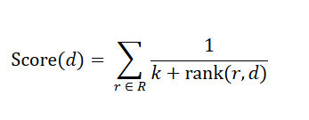
- rank(r,d): The position of the document in a search result list (1st, 2nd, etc.)
- K: A smoothing constant, typically set to 60

This architecture takes advantage of the complementary strengths of dense and sparse retrieval:
- Dense Retrieval (ChromaDB Cosine Similarity Search with MedEmbed-large embeddings) provides a semantic equivalence match between the query and chunk text, despite having varied terms, but having the same meaning in the clinical language.
- Sparse Retrieval (BM25 TF-IDF Keyword Search) captures exact lexical matches for specific dressing type names, drug names, and clinical terminology that may be missed from semantic search (Madrid-García et al., 2025).

The RRF is used to fuse and re-rank the list of candidate chunks retrieved from both dense and sparse retrievers, and generate a single ranked list. The top-k chunks of the fused ranking will be sent to the generation pipeline. In the proposed initial configuration, the top-6 chunks are retrieved altogether in all the sub-queries. The effects of retrieval methods on retrieval quality will be assessed in the Retrieval Ablation Study.

3.5 Generation Pipeline
The generation pipeline is responsible for taking the retrieved chunks of clinical guidance and the structured T.I.M.E. input payload to generate an evidence-grounded wound dressing recommendation using a Large Language Model (LLM). The proposed generation pipeline uses the GPT-4o-mini LLM through OpenAI API, set with a temperature of 0 to generate deterministic output. This deterministic setting ensures that the results obtained in the evaluations are reproducible across different evaluation runs, to isolate the contribution of individual retrieval design decisions.

The proposed prompt architecture for the VerdaSenseRAG’s generation pipeline is a grounded system prompt design, which consists of four parts: (1) The LLM is given a role as a Clinical Wound Care Consultant, (2) Explicit grounding instructions require the LLM to cite source numbers from the retrieved chunks to prevent the model from hallucinating without corresponding evidence, (3) The retrieved guideline chunks are injected into the retrieved context as numbered evidence blocks, and (4) The structured output schema is written across all nine output fields.

3.6 Evaluation Framework and Proposed Ablation Study
VerdaSenseRAG evaluation framework is a combination of automated llm-as-a-judge evaluation, rule-based safety check and human-in-the-loop clinical evaluation by clinical expert to assess the performance of the system in three areas: (1) Retrieval quality, (2) Generation quality, and (3) Clinical safety. Evaluation consists of a systematic ablation study on a fixed testset and fixed automated evaluation framework both in the retrieval and in the generation pipeline.

3.6.1 Testset Construction
A special evaluation test set verified by a clinical expert has been built, which constitutes 32 test cases for the main, clinically complex and edge cases represented in the knowledge base. The test set is segmented into five categories of wounds:
Category | Cases (n) | Description
A | 8 | Primary care wound types, including clean and low-complexity wounds managed in the community settings (wound types 1-8 per GP/WCM algorithm)
B | 12 | Intermediate complexity, including infected, high exudate, or multi-factor wounds requiring dressing combination decisions
C | 6 | High necrotic burden or debridement indicated wounds (>25% non-viable tissue)
D | 4 | Referral indicated cases where wounds meet hospital escalation criteria
E | 2 | Edge cases and challenging presentations (e.g. mixed tissue with conflicting T.I.M.E labels)

Table 4: Test Set Construction
Each case in the test set consists of 6 basic fields of structured information:
- A structured T.I.M.E. input payload (generated by the upstream models),
- The reference answer (the clinical recommendation expected from the test case),
- The reference context chunks from the knowledge base
- An allowed dressing list
- A contraindicated dressing list
- A list of binary flags indicating antibiotic and referral needs
The construction of these fields is consulted with a clinical collaborator and is directly based on the source documents in the knowledge base to ensure consistency between the reference answer fields and safety fields, and consistency with the guideline evidence available for retrieval.

It is acknowledged that the test set may be modified or expanded during the ablation study as needed to align with changes in the knowledge base or to enhance wound type category coverage, in discussion with the clinical collaborator.

3.6.2 Automated RAGAS Evaluation Framework
The automated evaluation framework for this project is based on the LLM-as-a-judge framework in the original paper on RAGAS (Es et al., 2023). Es et al. demonstrated that LLMs could effectively measure the fundamental qualities of RAGs (e.g. Faithfulness and Answer Relevance) in a scalable way, with minimal dependence on human annotators in their original paper. In this project, the RAGAS approach is expanded into the wound care domain by utilizing a “golden testset” verified by a clinical expert, which consists of reference contexts and reference answers. This curated ground truth extends beyond the paper’s original reference-free limitations, allowing the RAGAS framework to accurately measure Context Precision and Context Recall in addition to the traditional evaluation metrics, providing domain-specific assessment of the RAG pipelines.
For VerdaSenseRAG ablation study, the RAGAS LLM judge is fixed as OpenAI’s GPT-4o-mini and OpenAI’s text-embedding-small as an embedding-based scorer across all experiments. The judge and scoring models are fixed throughout all retrieval and generation ablation experiments to ensure comparability and consistency of scores across experiments. The full evaluation metric suite is divided into retrieval-based and generation-based metrics:

Metric | Type | Description
Context Recall (CR) | RAGAS LLM | Measures the fraction of reference context information covered by retrieved chunks, used for retrieval completeness
Context Precision (CP) | RAGAS LLM | Measures the fraction of retrieved chunks that are actually relevant, used to indicate retrieval noise and ranking quality
Hit rate @ K (HR@K) | IR Metric | Binary measure of whether at least one reference chunk appears in the top-K retrieved chunks
Mean Reciprocal Rank (MRR) | IR Metric | Average reciprocal rank of the first relevant chunk across all test cases
NDCG @ K | IR Metric | Normalized Discounted Cumulative Gain, a graded ranking quality metric, rewards relevant chunks that are ranked higher
Recall @ K (R@K) | IR Metric | Fraction of reference chunks found in top-K retrieved results
Precision @ K (P@K) | IR Metric | Fraction of top-K retrieved chunks that are relevant to reference chunks
Retrieval Latency (ms) | System | Wall clock time for a complete retrieval step

Table 5: Retrieval Ablation Metric Suites
Metric | Type | Description
Faithfulness (FA) | RAGAS LLM | Measures the proportion of claims in the generated answer that are grounded by the retrieved context
Answer Relevancy (AR) | RAGAS Embedding | Measures the semantic relevance of the generated answer to the original clinical query (T.I.M.E. input)
Safety Pass Rate (%) | Rule-based | Binary PASS/FAIL safety checker per test case, evaluating (1) dressing in the allowed list, (2) antibiotic recommendation, (3) referral criterion accuracy, and (4) absence of contraindicated dressings in recommendations
Generation Latency (ms) | System | Wall clock time for the LLM generation
Total Latency (ms) | System | End-to-end wall clock time

Table 6: Generation Ablation Metric Suites

3.6.3 Rule-Based Safety Checker
Each generated recommendation is evaluated through a rule-based safety checker that provides an overall PASS or FAIL label depending on three deterministic safety criteria: (1) whether the recommended primary dressing is listed in the allowed dressing list for the test case wound type, (2) whether the antibiotic recommended is clinically appropriate based on the antibiotic_required Boolean field for each case, (3) whether the referral or escalation recommendation matches the test case’s referral_required Boolean field, and (4) whether there is contraindicated dressings present in the primary and secondary dressing generated. This rule-based safety evaluation can complement the LLM-judged RAGAS metric in a deterministic and standardized clinical safety evaluation.

3.6.4 Human Clinical Expert Evaluation
A small portion of the generated recommendations will be evaluated by the expert clinical collaborator, who is also a clinical collaborator for the project, to evaluate dimensions of recommendation quality that automated measures may not be able to capture. The proposed human evaluation will be of about 20-30% of the test set, selecting cases to represent a variety of wound types, levels of complexity and edge cases.

3.6.5 Proposed Ablation Study Design
The ablation study is carried out as a sequential two-stage evaluation, where retrieval design decisions are evaluated at Stage 1 while the generation pipeline remains unchanged, and generation design decisions are tested at Stage 2 with the fixed retrieval pipeline at the best configuration found in Stage 1. This sequential single variable per experiment design allows all of the observed performance changes to be assigned to the variable being tested.
To address the stochastic (randomness) variation in RAGAS LLM-judge scoring, each experiment will be repeated 3 times, and the mean and standard deviation will be recorded.

Stage 1 – Proposed Retrieval Ablation Experiments
The proposed retrieval ablation study consists of four experiments without an LLM generation stage, and the winner of each experiment is fixed as a constant for subsequent experiments to create a controlled optimization chain:

Exp | Research Question | Variants | Fixed Variables
R1 | Does the way the TIME inputs are turned into a retrieval query affect what chunks are retrieved? | R1-A: Flat label concatenation  R1-B: Narrative natural language query (LLM generated)  R1-C: Multi-axis sub-query decomposition (proposed) | Dense retrieval with k=6  MedEmbed-large as an embedding model
R2 | Does adding sparse BM25 or cross-encoder reranking improve retrieval over dense-only search? | R2-A: Dense-only  R2-B: Sparse-only (BM25)  R2-C: Hybrid Dense & BM25 with RRF (proposed)  R2-D: Hybrid & cross-encoder reranker (variants) | Best R1 query with k=6  MedEmbed-large as an embedding model
R3 | How does the number of retrieved chunks (Top-K) affect the retrieval precision and recall? | R3-A: k=2  R3-B: k=4  R3-C: k=6 (proposed)  R3-D: k=8 | Best R1 query, Best R2 Retrieval Method  MedEmbed-large as an embedding model
R4 | Does the choice of embedding model affect retrieval quality for wound care guideline text? | R4-A: MedEmbed-large-v0.1 (proposed)  R4-B: BGE-large-en-v1.5  R4-C: E5-large-v2 | Best R1, Best R2, Best R3

Table 7: Proposed Retrieval Ablation Experiments

Stage 2 – Proposed Generation Ablation Experiments
The following experiments constitute the proposed generation ablation study. All experiments hold the retrieval pipeline constant at the best configuration in Stage 1:

Exp | Research Question | Variants | Fixed Variables
G1 | How much does prompt strategy contribute to faithfulness, answer relevancy and safety? | G1-A: Zero-shot (raw T.I.M.E. only)  G1-B: Basic structured output  G1-C: Grounded system prompt (proposed)  G1-D: Full clinical scaffolding (pre-classifier + mandatory injection) | GPT-4o-mini as Generation LLM, best retrieval design from Stage 1
G2 | Do closed-source LLMs differ meaningfully in generation quality and latency for wound care recommendations? | G2-A: GPT-4o-mini (proposed)  G2-B: GPT-4o  G2-C: Gemini 2.5 Flash-Lite  G2-D: Gemini 2.5 Flash | Best G1 prompt strategy, Best Retrieval design from Stage 1
G3 | Can open-source LLMs match closed-source performance for wound dressing recommendation generation? | G3-A: Qwen3 14B  G3-B: Gemma 3 12B  G3-C: Llama 3.2 11B  G3-D: Gemma 4 26B A4B | Best G1 prompt strategy, Best Retrieval design from Stage 1

Table 8: Proposed Generation Ablation Experiments
It is emphasized that the ablation study will be proposed as future work and will be carried out over time, so no determinations are made on the optimum configuration of the architecture. The design of the ablation study described above is a systematic plan that will be used for experiments to determine the optimal retrieval and generation configuration, and the results will be presented in the final Project Report in Academic Project 2 (AP2) with the discussion of the results and their clinical implications. The knowledge base and test set will also be continually updated with the help of retrieval and generation analysis throughout the ablation study, as well as based on discussion with the clinical collaborator.

4.0 System Analysis and Design

4.1 Architecture Pipelines
This section presents the overall system design and architecture of VerdaSense RAG through 4 pipeline diagrams. Each diagram corresponds to a specific pipeline of the system and illustrates the end-to-end flow from patient-captured wound image submission to the generation of structured evidence-grounded dressing recommendations.

4.1.1 Knowledge Base Ingestion Pipeline
The Knowledge Base (KB) Ingestion Pipeline is shown in Figure 4.1.1. This pipeline is run offline before the system is deployed, and the ChromaDB vector store is built to store chunks for the retrieval process. The first step in the pipeline will be the collection and selection of eight clinical wound care guidelines, followed by manually preprocessing and noise reduction with removal of irrelevant sections, and content-aware semantic chunking are performed. Each curated chunks is then added to ChromaDB along with a structured metadata using embedding model.

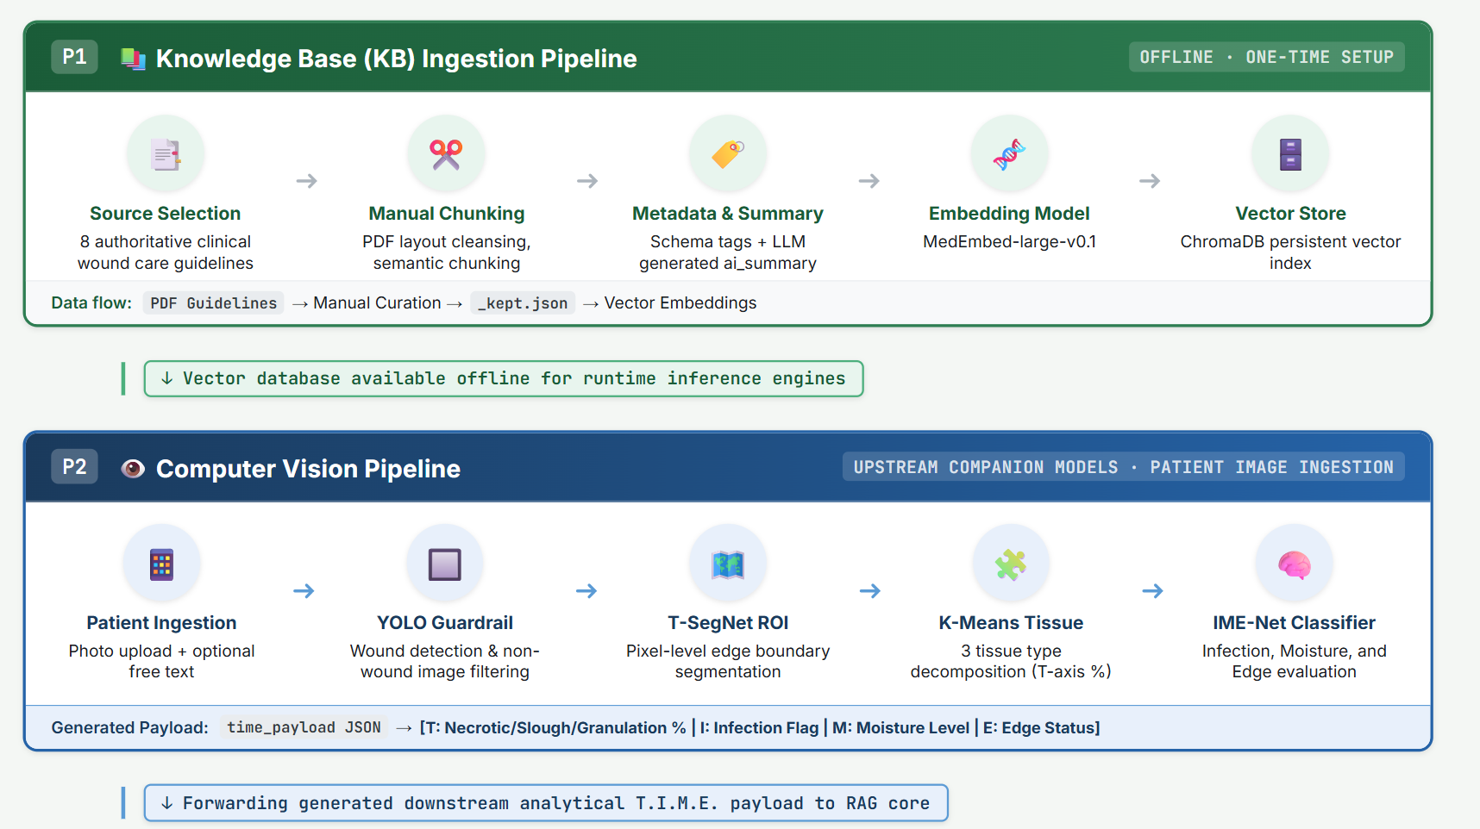

Figure 1: VerdaSense RAG Ingestion Pipeline

4.1.2 Retrieval and Generation Pipeline
Figure 4.1.2 shows the Retrieval and Generation Pipelines, which will be executed at inference time when a API request is received from user-end. The Retrieval Pipeline starts by T.I.M.E. input normalization and a rule-based clinical pre-classifier is responsible to map the T.I.M.E. data for each wound type. The multi-axis sub-query decomposition strategy then generates three semantically different sub-queries, which are subsequently used for chunks retrieval from the ChromaDB vector using hybrid retrieval with Reciprocal Rank Fusion (RRF).

The top K chunks fused from RRF are being passed to the Generation Pipeline. The generator LLM (gpt-4o-mini, temperature=0, max_tokens=2048) is responsible to generate a grounded dressing recommendation based on the top retrieved chunks injected in its context which a grounded system prompt, allowing it to explicitly cite guideline evidence blocks to reduce hallucinations.

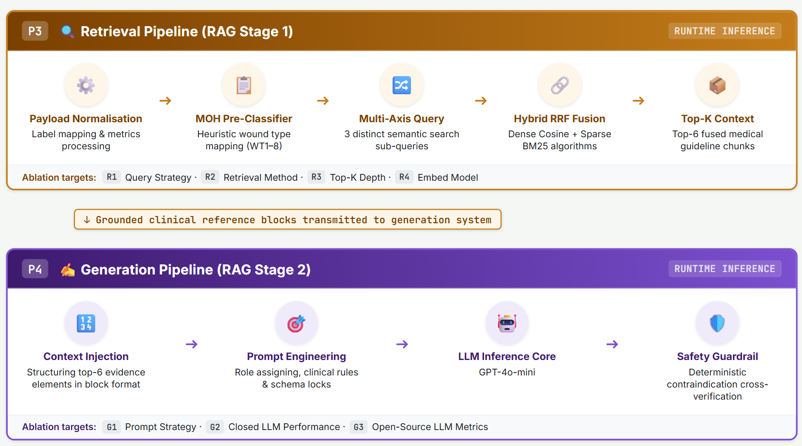Figure 2: VerdaSense RAG Retrieval & Generation Pipelines

4.1.3 Evaluation Pipeline
Figure 4.1.3 represents the Evaluation Pipeline. The testset comprises of 32 wound cases (Categories A-E), each containing a structured T.I.M.E. input payload, a reference ground-truth answer, reference context chunks, allowed and contraindicated dressing lists, and antibiotic and referral flags. The primary automated RAGAS evaluation framework uses fixed LLM-as-judge across all ablation experiments. The RAGAS evaluation framework measures the 4 metrics across retrieval (Context Recall, Context Precision) and generation (Faithfulness, Answer Relevancy) dimensions. Besides, a rule-based Safety Checker evaluates each recommendation for dressing validity, antibiotic and referral compliance, and the absence of contraindications. A targeted subset of generated recommendations will be reviewed by the clinical collaborator, Ms. Saw Shier Khee, for human clinical validation of accuracy, completeness, and clinical preference.
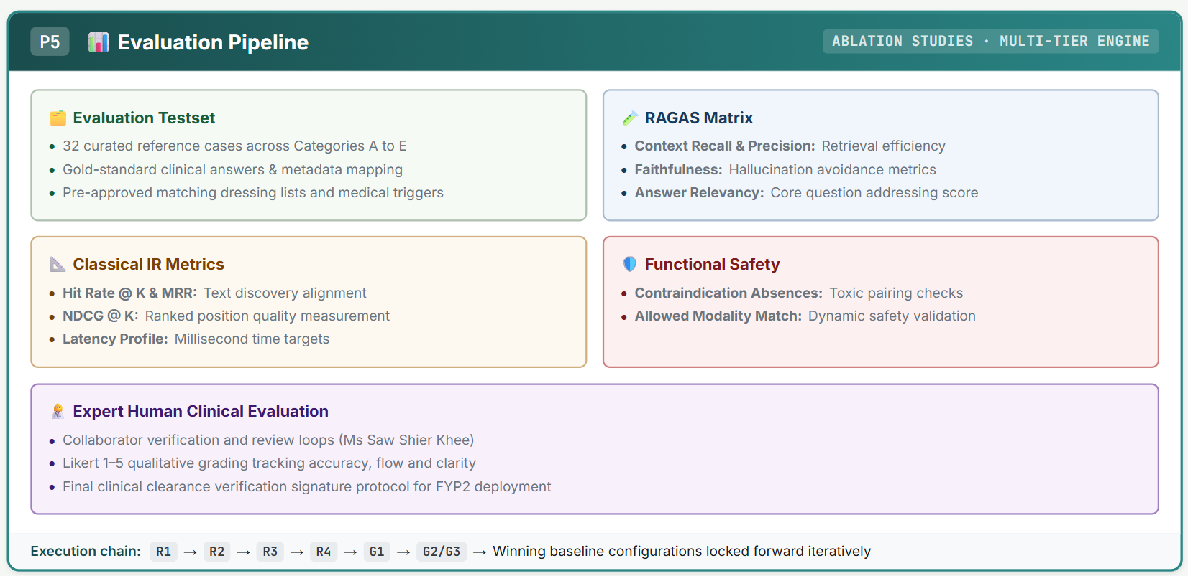

Figure 3: VerdaSense RAG Evaluation Pipeline

4.2 Requirements Analysis

4.2.1 Functional Requirements
No. | Functional Requirements | Description
1 | Optional Clinical Notes | System accepts optional free-text clinical notes from patients, incorporate into retrieval
2 | T.I.M.E. Input Processing | System accepts structured wound TIME assessment inputs as generated by companion K-Means Clustering & IME-Class Net Classification models
3 | Knowledge Base Retrieval | System retrieves most clinically relevant guideline passages from ChromaDB vector store, using hybrid dense and sparse retrieval with RRF score Fusion
4 | Grounded Recommendation Generation | System generates structured wound dressing recommendation from retrieved guidelines, including Primary/Secondary Dressings, TIME rationale, etc.
5 | Evaluation Pipeline | System supports automated RAGAS Evaluation of generated recommendations against test sets (CP, CR, FA, AR & Safety Pass Rate)
6 | Mobile Integration | System exposes RESTful API endpoint accessible from mobile app, via HTTP POST

Table 9: Functional Requirements

4.2.2 Non-functional Requirements
No. | Non-Functional Requirements | Description
1 | Response Latency | The end-to-end pipeline (retrieval & generation) shall return recommendation within an acceptable time under normal network condition
2 | Clinical Safety | System shall not produce recommendations containing contraindicated dressings.
3 | Evidence Grounding | The recommendations generated shall be based on retrieved guideline passages (Faithfulness)
4 | Retrieval Completeness | Retrieval shall recover all ground-truth clinically relevant information (Context Recall)
5 | Explainability | System shall expose retrieved source documents used to generate recommendations, enable clinicians to verify evidence
6 | Security & Data Privacy | No patient clinical data shall be retained by the VerdaSense RAG beyond the scope of a single recommendation

Table 10: Non-functional Requirements

5.0 Technical Implementation
Category | Tools &  Technology | Functionality
Core Development & Backend | FastAPI | Develop high-performance, production-ready RESTful API endpoints
 | Uvicorn | Serves as the lightning-fast web server used to run the FastAPI application locally
 | Pydantic | Enforces strict data validation and runtime type-checking.
Artificial Intelligence & RAG Core | LangChain Framework | Primary LLM orchestration layer to manage prompt architectures and context injection
 | Chroma (ChromaDB) | Embedding-backed vector store to run dense semantic similarity searches.
 | PyTorch & Sentence-Transformers | Provides the deep learning framework to execute text embedding models locally.
 | RAGAS (RAG Assessment) | Deployed as the automated evaluation framework.
Model Platforms & APIs | OpenRouter | Employed as an API gateway interface to evaluate open-source models
 | OpenAI API | Used to query LLMs, acting as the system’s foundational configuration baseline.
 | Google AI Studio (Gemini API) | Google's generative models to measure domain-specific generation efficiency.
Productivity & Lifecycle Management | VS Code | Integrated Development Environment (IDE) for writing code and debugging.
 | Git & GitHub | Employed for secure codebase version control and tracking iterations.
 | Google Docs & Google Sheets | Manage documentation with supervisors and collaborators.

Table 11: Technical Implementations

6.0 Conclusion
The proposed evidence-based Retrieval-Augmented Generation (RAG) system for wound dressing recommendations, VerdaSense RAG, addresses four major research gaps in the field of wound care AI, clinical decision support and mobile health. Prior computer vision models either stopped at wound assessment without offering dressing recommendations, prone to LLM hallucinations, lack of study of structured T.I.M.E. labels for RAG retrieval, or remained theoretical without mobile deployment capability.

VerdaSense RAG bridges these gaps by integrating computer vision assessment pipeline with a specialized clinical RAG architecture, which comprises of different features including curated clinical wound guidelines as knowledge base, multi-axis hybrid retrieval strategy, grounded generation prompt architecture, and an end-to-end smartphone deployable pipeline designed for near real-time and patient-facing mobile applications for safer AI-assisted self-care.

7.0 References
Abdolahnejad, M., Mashayekhi, N., Kyremeh, M., Smith, J., Chan, M., Fang, G., Jegatheeswaran, T., Chan, H. O., Joshi, R., & Hong, C. (2026). A mobile AI-enhanced platform for standardized wound assessment and clinical decision support. medRxiv. https://doi.org/10.64898/2026.01.22.26344407
Agnihotram, G., & Sarkar, J. (2025). Evaluating precision and recall at retrieval time in Retrieval-Augmented Generation (RAG) Systems. American Journal of Computer Science and Technology, 8(4), 174–180. https://doi.org/10.11648/j.ajcst.20250804.11
Alu, F. F., & Oluwadare, S. (2026). An auditable and source-verified framework for clinical AI decision support: integrating retrieval-augmented generation with data provenance. Frontiers in Artificial Intelligence, 9, 1737532. https://doi.org/10.3389/frai.2026.1737532
Brown, T. B., Mann, B., Ryder, N., Subbiah, M., Kaplan, J., Dhariwal, P., Neelakantan, A., Shyam, P., Sastry, G., Askell, A., Agarwal, S., Herbert-Voss, A., Krueger, G., Henighan, T., Child, R., Ramesh, A., Ziegler, D. M., Wu, J., Winter, C., . . . Amodei, D. (2020, May 28). Language Models are Few-Shot Learners. arXiv.org. https://arxiv.org/abs/2005.14165
Busaranuvong, P., Agu, E., Fard, R. S., Kumar, D., Gautam, S., Tulu, B., & Strong, D. (2025, February 27). Explainable, Multi-modal Wound Infection Classification from Images Augmented with Generated Captions. arXiv.org. https://arxiv.org/abs/2502.20277
Chadwick, P. (2025, October 13). The role of artificial intelligence in wound care: applications, evidence and future directions. Wounds International. https://woundsinternational.com/journal-articles/the-role-of-artificial-intelligence-in-wound-care-applications-evidence-and-future-directions/
Falanga, V., Isseroff, R. R., Soulika, A. M., Romanelli, M., Margolis, D., Kapp, S., Granick, M., & Harding, K. (2022). Chronic wounds. Nature Reviews Disease Primers, 8(1), 50. https://doi.org/10.1038/s41572-022-00377-3
Garten, A., Bellingeri, A., Weir, D., Stürmer, E., Tariq, G., Post, H., Swan, J., Carville, K., Ruotsi, L., Clark, M., Jelnes, R., Ayabe, S., Swanson, T., & Moore, Z. (2020, September 9). Strategies to reduce practice variation in wound assessment and management: The T.I.M.E. Clinical Decision Support Tool. Wounds International. https://woundsinternational.com/world-union-resources/strategies-reduce-practice-variation-wound-assessment-and-management-time-clinical-decision-support-tool/
Huang, L., Yu, W., Ma, W., Zhong, W., Feng, Z., Wang, H., Chen, Q., Peng, W., Feng, X., Qin, B., & Liu, T. (2024). A survey on hallucination in large language models: principles, taxonomy, challenges, and open questions. ACM Transactions on Information Systems, 43(2), 1–55. https://doi.org/10.1145/3703155
Leaper, D. J., Schultz, G., Carville, K., Fletcher, J., Swanson, T., & Drake, R. (2012). Extending the TIME concept: what have we learned in the past 10 years?*. International Wound Journal, 9(s2), 1–19. https://doi.org/10.1111/j.1742-481x.2012.01097.x
Madrid-García, A., Benavent, D., Plasencia-Rodríguez, C., Rosales-Rosado, Z., Merino-Barbancho, B., & Freites-Núñez, D. (2025). Optimising the clinical application of rheumatology guidelines using large language models: a retrieval-augmented generation framework integrating EULAR and ACR recommendations. EULAR Rheumatology Open, 1(3), 228–236. https://doi.org/10.1016/j.ero.2025.08.001
Nagle, S. M., Stevens, K. A., & Wilbraham, S. C. (2023, June 26). Wound assessment. StatPearls - NCBI Bookshelf. https://www.ncbi.nlm.nih.gov/books/NBK482198/
Potluri, D., Mathew, A. M., DeWitt, J. B., Rasgon, A. L., Hao, Y., Hong, J., & Ding, Y. (2025, November 20). CARE-RAG - Clinical Assessment and Reasoning in RAG. arXiv.org. https://arxiv.org/abs/2511.15994
Rabbani, M. G., Alam, A., & Prybutok, V. R. (2025). Digital Health Transformation Through Telemedicine (2020–2025): Barriers, Facilitators, and Clinical Outcomes—A Systematic Review and Meta-Analysis. Encyclopedia, 5(4), 206. https://doi.org/10.3390/encyclopedia5040206
Rackauckas, Z. (2024). Rag-Fusion: a new take on retrieval augmented generation. International Journal on Natural Language Computing, 13(1), 37–47. https://doi.org/10.5121/ijnlc.2024.13103
Rochon, M., Tanner, J., Jurkiewicz, J., Beckhelling, J., Aondoakaa, A., Wilson, K., Dhoonmoon, L., Underwood, M., Mason, L., Harris, R., & Cariaga, K. (2024). Wound imaging software and digital platform to assist review of surgical wounds using patient smartphones: The development and evaluation of artificial intelligence (WISDOM AI study). PLoS ONE, 19(12), e0315384. https://doi.org/10.1371/journal.pone.0315384
Schultz, G. S., Sibbald, R. G., Falanga, V., Ayello, E. A., Dowsett, C., Harding, K., Romanelli, M., Stacey, M. C., Teot, L., & Vanscheidt, W. (2003). Wound bed preparation: a systematic approach to wound management. Wound Repair and Regeneration, 11(s1), S1-28. https://doi.org/10.1046/j.1524-475x.11.s2.1.x
Sen, C. K., Gordillo, G. M., Roy, S., Kirsner, R., Lambert, L., Hunt, T. K., Gottrup, F., Gurtner, G. C., & Longaker, M. T. (2009). Human skin wounds: A major and snowballing threat to public health and the economy. Wound Repair and Regeneration, 17(6), 763–771. https://doi.org/10.1111/j.1524-475x.2009.00543.x
Vestjens, J. J., Rondas, A. A., White, R. R., & Holloway, S. S. (2017). The inter‐rater reliability between nurse‐assessors clinically assessing infection of chronic wounds using the WUWHS criteria. International Wound Journal, 15(1), 8–15. https://doi.org/10.1111/iwj.12785
Waikar, S., Bhat, A. G., & Ramanathan, M. (2026). Retrieval augmented generation ( RAG ) for evaluating regulatory compliance of drug information and clinical trial protocols. CPT Pharmacometrics & Systems Pharmacology, 15(3), e70201. https://doi.org/10.1002/psp4.70201
Wu, K., Wu, E., Wei, K., Zhang, A., Casasola, A., Nguyen, T., Riantawan, S., Shi, P., Ho, D., & Zou, J. (2025). An automated framework for assessing how well LLMs cite relevant medical references. Nature Communications, 16(1), 3615. https://doi.org/10.1038/s41467-025-58551-6
Xiong, G., Jin, Q., Lu, Z., & Zhang, A. (2024, February 20). Benchmarking Retrieval-Augmented Generation for medicine. arXiv.org. https://arxiv.org/abs/2402.13178
Yim, W., Abacha, A. B., Yetisgen-Yildiz, M., & Xia, F. (2025, October 1). Overview of the MEDIQA-WV 2025 Shared Task on Woundcare Visual Question answering. ACL Anthology. https://aclanthology.org/2025.clinicalnlp-1.3/
Yogapriya, J., Chandran, V., Sumithra, M. G., Elakkiya, B., Ebenezer, A. S., & Dhas, C. S. G. (2022). Automated detection of infection in diabetic foot ulcer images using convolutional neural network. Journal of Healthcare Engineering, 2022, 1–12. https://doi.org/10.1155/2022/2349849
Zakka, C., Chaurasia, A., Shad, R., Dalal, A. R., Kim, J. L., Moor, M., Alexander, K., Ashley, E., Boyd, J., Boyd, K., Hirsch, K., Langlotz, C., Nelson, J., & Hiesinger, W. (2023, March 1). Almanac: Retrieval-Augmented Language Models for Clinical Medicine. arXiv.org. https://arxiv.org/abs/2303.01229
Zhu, G., Fu, Z., & Guo, G. (2025). Applications and prospects of artificial intelligence in wound healing. Regenesis Repair Rehabilitation., 1(4), 12–19. https://doi.org/10.1016/j.rerere.2025.08.001

Appendix
- Google Drive Link: https://docs.google.com/document/d/1D1HC14nX2-UqD8Z5uUMug6YTJWHx2S_pIL82G_GcF2M/edit?usp=sharing
- Google Sheet Link: https://docs.google.com/spreadsheets/d/1gc2VqwIdv33aiuCrlN-UCuE4J7-b5fXDmrQI1x_-G2E/edit?usp=sharing
- Testset & KB: https://drive.google.com/drive/folders/1M6SLJ2651zwdbm6YRV2aRWnWAGlK_lfX?usp=drive_link
- GitHub Repository: https://github.com/TeeQiJing/WoundDressingRAG

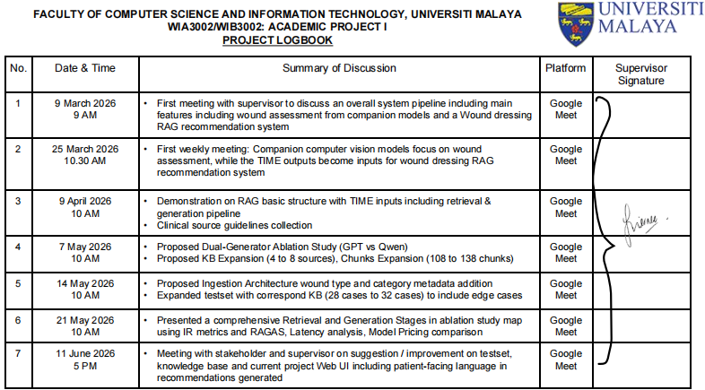

Figure 4: Logbook of meetings with supervisors

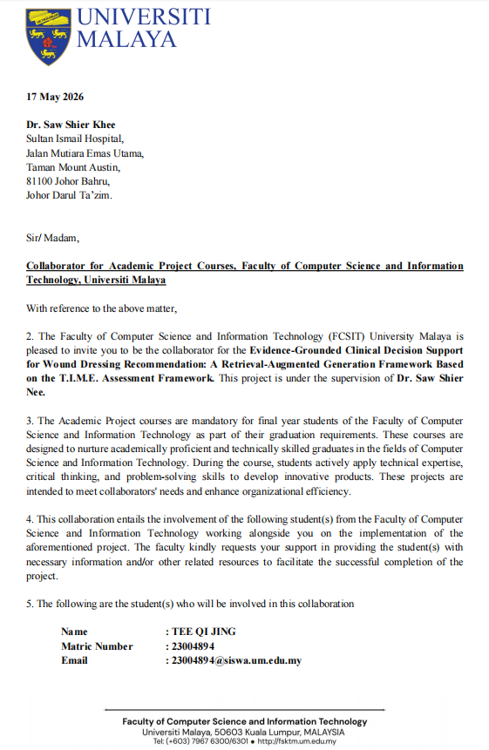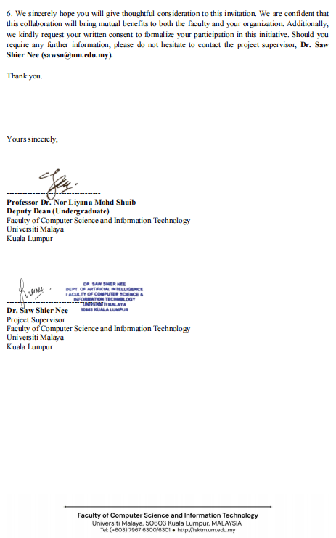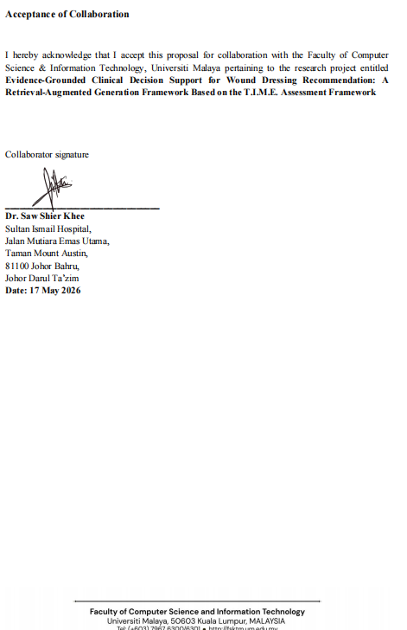

Figure 5: Collaboration Letter

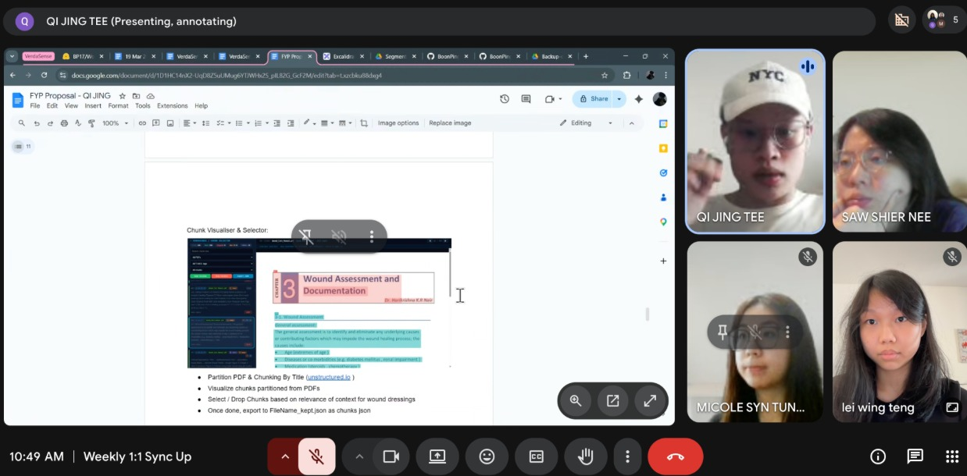

Figure 6: Meetings with supervisor
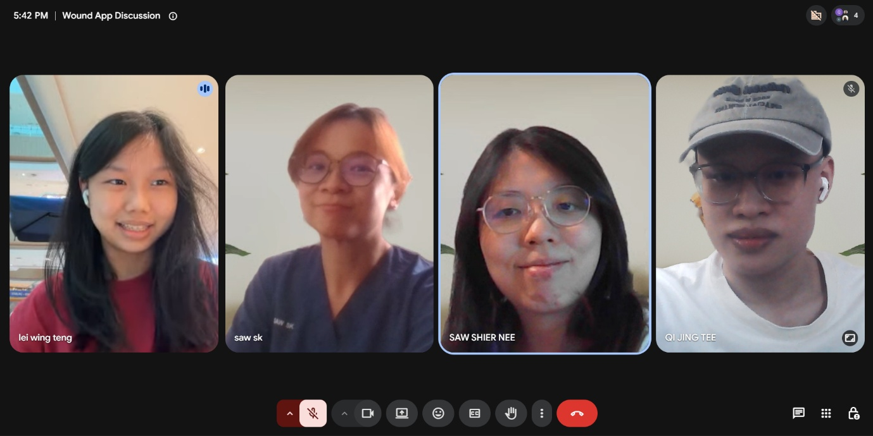

Figure 7: Meetings with collaborator

